# DESIGN

Main

# Initialize Scanner input

# Output: “Enter the number of rows and columns of the array”

# int rows <- input

# int columns <- input

# Output: “Enter the array”

# Initialize double 2d array array with size [rows][columns]

# For loop column, from 0 to columns:

# for loop row, from 0 to rows:

Array[row][column] <- input

# Initialize int array resultArray <- locateLargest (array)

### locateLargest ###

# Initialize int array largest as 2 element array

# Initialize double largestEntry <- array[0][0]

# For loop row, from 0 to length of array

# For loop column, from 0 to length of array[]

# if array[row][column] is greater than largestEntry:

# largestEntry <- array[row][column]

# largest[0] <- row

# largest[1] <- column  
 # Return largest

# Output: “The location of the largest element is at (x,y)”, where x and y are the values of resultArray

Design

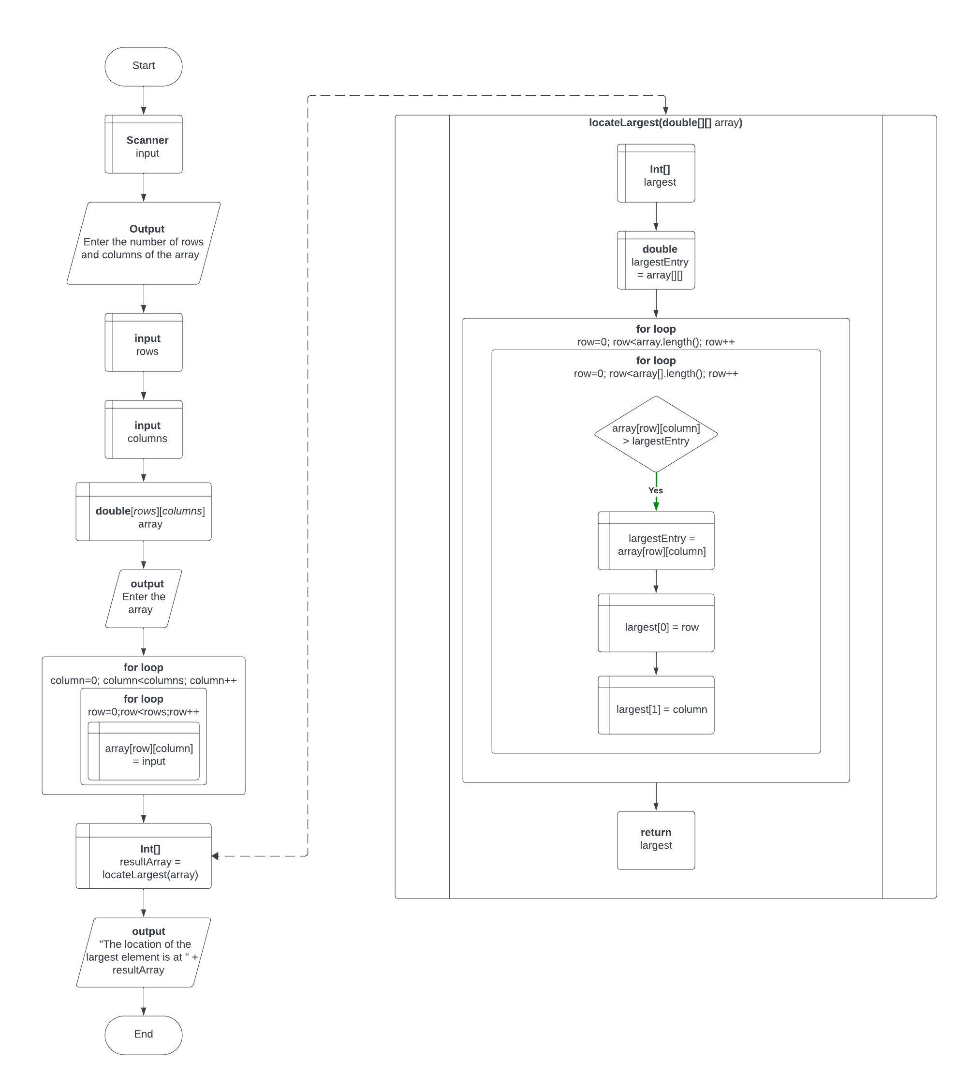

# TEST PLAN

|  |  |  |
| --- | --- | --- |
| Test # | Input | Expected Output |
| 1 | rows and columns of the array: 3 4  Enter the array:  23.5 35 2 10  4.5 3 45 3.5  35 44 5.5 9.6 | The location of the largest element is at (1, 2) |
| 2 | rows and columns of the array: 5 5  Enter the array:  33.9 34.2 24.25 75.381 60  01.8 24.1 26.39 10.189 98  94.7 93.3 90.54 84.209 01  68.0 86.2 49.47 24.7 62  61.2 82.9 17.68 58.822 39 | The location of the largest element is at (1, 4) |
| 3 | rows and columns of the array: 8 5  Enter the array:  01.8 24.1 26.39 10.189 98  23.5 35 2 10 18  33.9 34.2 24.25 75.381 60  35 44 5.5 9.6 89  4.5 3 45 3.5 9  61.2 82.9 17.68 58.822 39  68.0 86.2 49.47 24.7 62  94.7 93.3 90.54 84.209 01 | The location of the largest element is at (0, 4) |

# SCREEN SHOTS

1

2

3

